Product Specification

Specification:
Item |  | Unit | Spec. Value
Conductor | Wire No. | --- | 4P
 | Material | --- | Solid Bare Copper
 | Construction | No./mm | 0.57±0.02
Insulation | Material | --- | PE
 | Diameter | mm | 1.16±0.05
 | Color | --- | 1.Blue&White Blue 2.Orange&White Orange  3.Green&White Green 4.Brown&White Brown
Seperator | --- | / | Yes
Tape Wrap | Spec | mm | PET 100％Coverage
Foil Shield | Spec | mm | AL-Mylar 100％Coverage
Drain Wire | Material | --- | Tinned copper
 | Spec | mm | 0.4±0.05
Rip cord | --- | / | Yes
Jacket | Material | --- | PVC
 | Color | --- | Assorted upon request
 | Thickness | mm | 0.55±0.1
 | Diameter | mm | 7.8±0.5
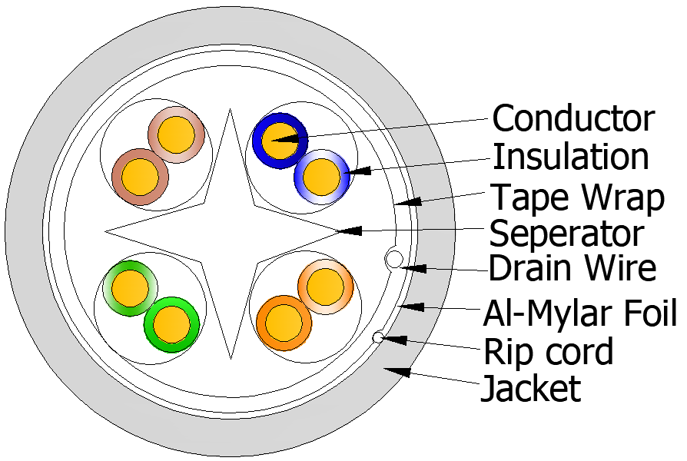
Sketch:

Application:
1: Material : Comply RoHS
Mechaniacl Specification：
Conductor Elongation | ≥10％
Insulation Tensile Strength | ≥16.5Mpa
Insulation Elongation | ≥300％
Jacket Tensile Strength | ≥13.8Mpa
Jacket Elongation | ≥100％

Electrical Specifications:
Impedance | 100±15Ω（1.0-100Mhz）
 | 100±22Ω（1.0-250Mhz）
Conductor Resistance @20°C | Max.9.38Ω/100m
DC Resistance Unbalance | Max.5％
Insulation Resistance | Min. 5000 MΩ*Km
Delay Skew | Max.45ns/100m
High Frequency Electrical Performance:(100m at 20℃)
Frequency（MHz） | ATT (≤dB) | NEXT (≥dB) | PSNEXT (≥dB) | ELFEXT (≥dB) | PS ELFEXT (≥dB) | RL (≥dB) | Spread out 100m cable and test it
1.00 | 2.0 | 74.3 | 72.3 | 67.8 | 64.8 | 20.0
4.00 | 3.8 | 65.3 | 63.3 | 55.8 | 52.8 | 23.0
8.00 | 5.3 | 60.8 | 58.8 | 49.7 | 46.7 | 24.5
10.00 | 6.0 | 59.3 | 57.3 | 47.8 | 44.8 | 25.0
16.00 | 7.6 | 56.2 | 54.2 | 43.7 | 40.7 | 25.0
20.00 | 8.5 | 54.8 | 52.8 | 41.8 | 38.8 | 25.0
25.00 | 9.5 | 53.3 | 51.3 | 39.8 | 36.8 | 24.3
31.25 | 10.7 | 51.9 | 49.9 | 37.9 | 34.9 | 23.6
62.50 | 15.4 | 47.4 | 45.4 | 31.9 | 28.9 | 21.5
100.00 | 19.8 | 44.3 | 42.3 | 27.8 | 24.8 | 20.1
200.00 | 29.0 | 39.8 | 37.8 | 21.8 | 18.8 | 18.0
250.00 | 32.8 | 38.3 | 36.3 | 19.8 | 16.8 | 17.3

